Courtney Thurston

AP Art History

Mrs. Eckel

Early South and Southeast Asian Art

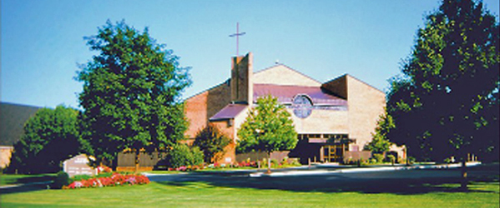

The image above is a photograph of St. Joseph’s Catholic Church in Mechanicsburg, Pennsylvania. Growing up, my mother and I attended mass every Thursday and Sunday, and I believe that St. Joseph’s is a fantastic example of a contemporary sacred space due to its architecture. Much like Ottoman mosques and Gothic Cathedrals, St. Joseph’s utilizes both height and light to create a sacred space for worshippers. The ceiling is wide and pointed at the top, while stained glass windows line the sides of a church—a rose window pictured in the center above the narthex. These artistic details create an atmosphere of holiness, and the church is thus an example of a modern-day sacred space.